Overview of the Patient Portal
The Patient Portal is a secure website that will allow you to communicate with us in a fast, reliable and easy-to-use fashion for non-urgent communications.
The features of the Patient Portal include:
*Send and receive secure messages for medical, front desk, referral or billing questions including secure message
*View and pay statements
*Receive and review documents (immunization record, school excuse, physical form)
*Request and view appointments
*Send us attachments
*Request medication refills
*Research Center featuring: Healthwise Patient Education, Interactive Tools and Learning Center
Your invite is on the way to the email we have on file. You will be enrolling as your child’s guardian. 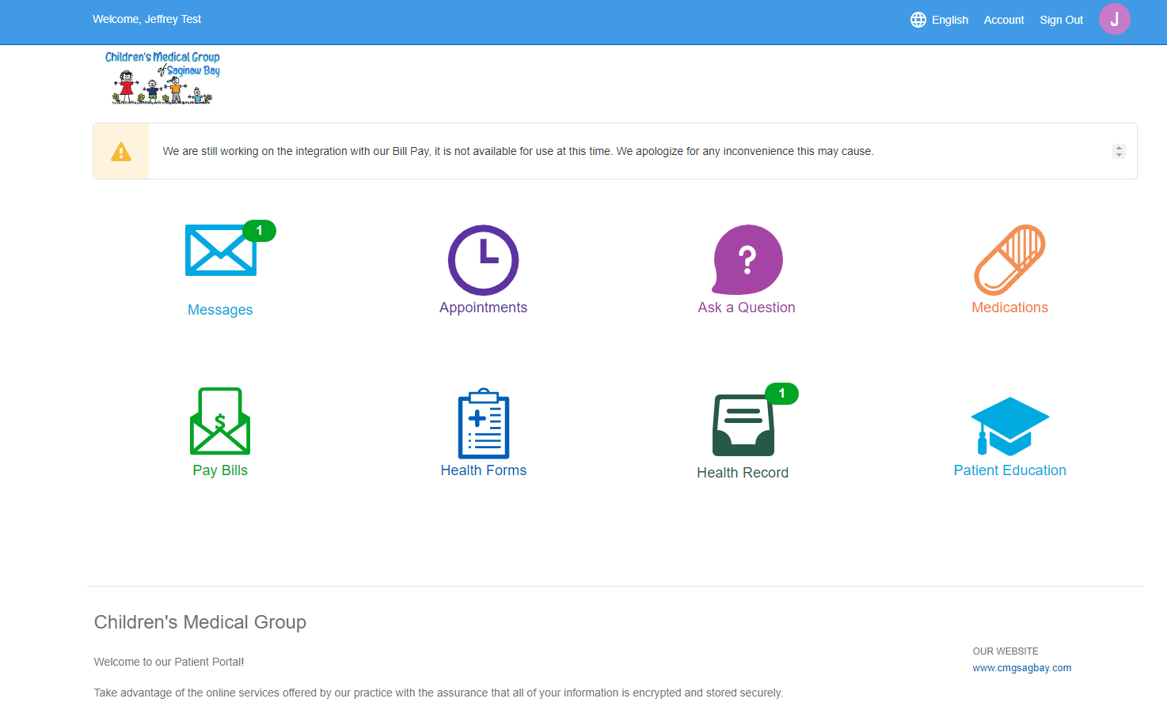
Sample of Invitation Email to start the sign-up process of our new portal pppportalportal.
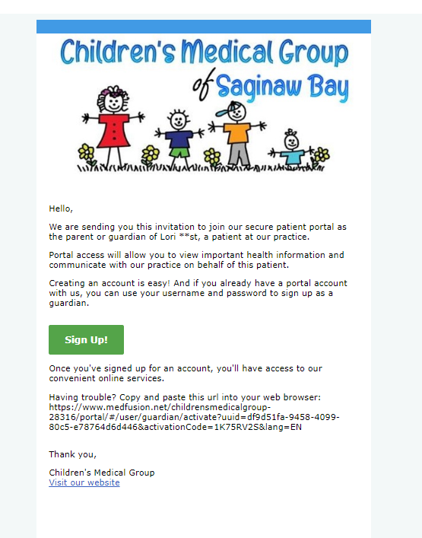

Step 1. Input patients Zip code and patients date of birth. Choose continue.

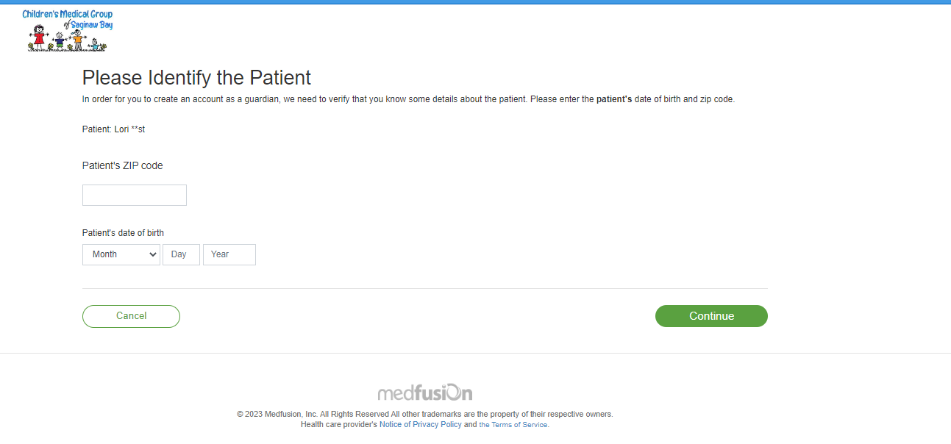

IMPORTANT!! STEP 2. First Time Users Must create an Account. Change first name and last name to parent or guardian. Choose continue.
If you have an existing account, log in to add your child to your account- see page 6 for additional instructions.

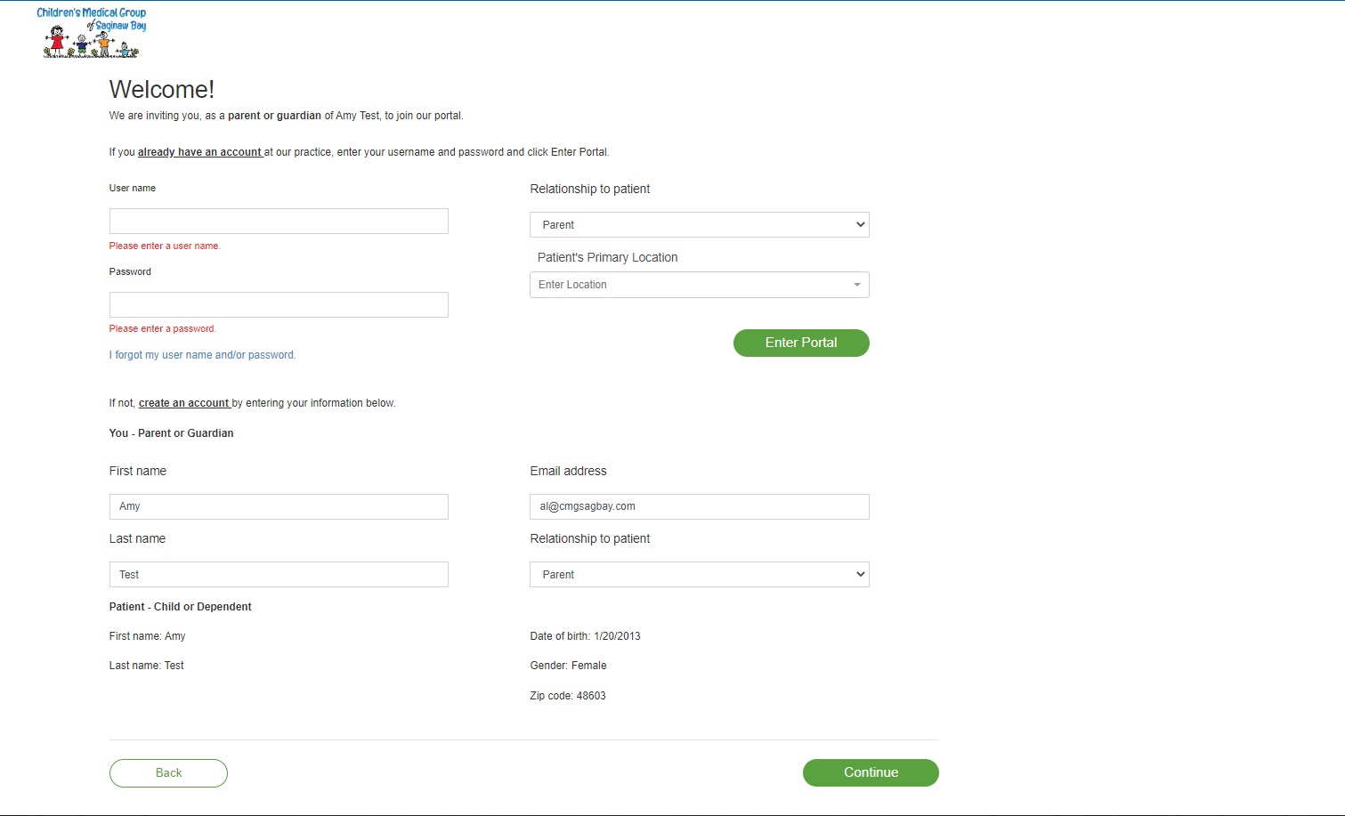

Step 3. Create Security Detail, be sure to complete all blank areas, then choose enter portal.

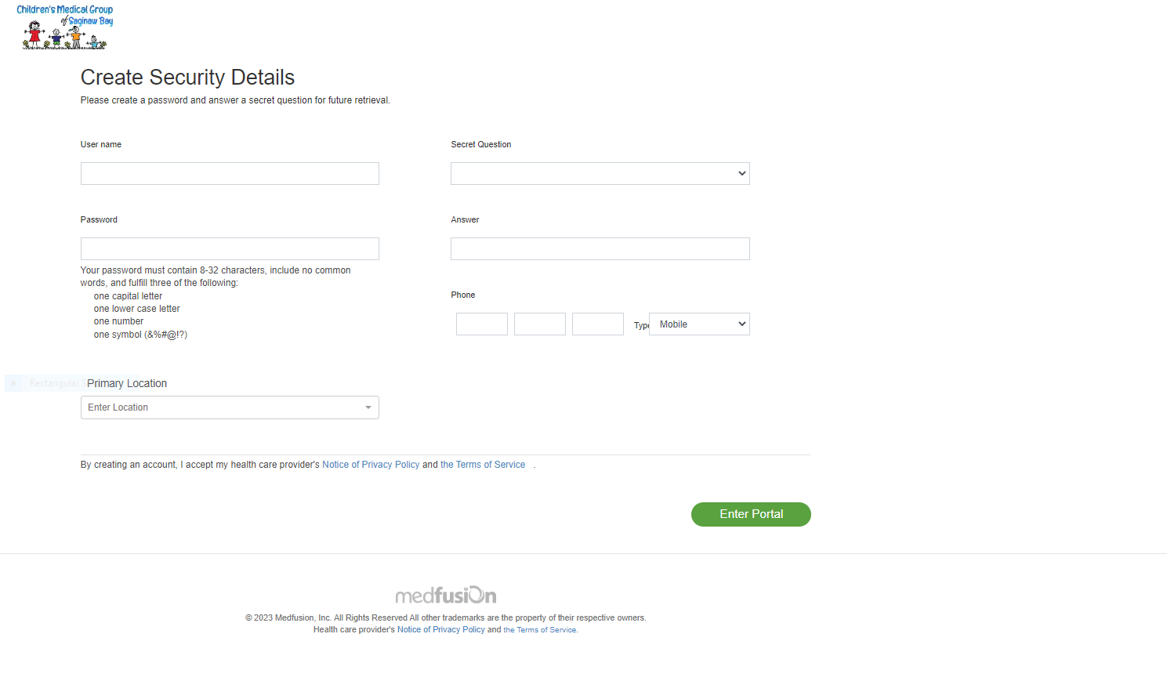

Adding sibling to an existing account.
Use “already have an account”
Use the user name and password that was used to create your “First time user account” And choose Enter Portal

