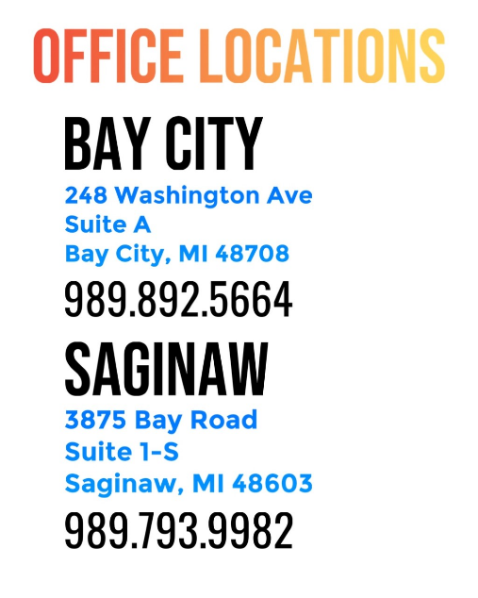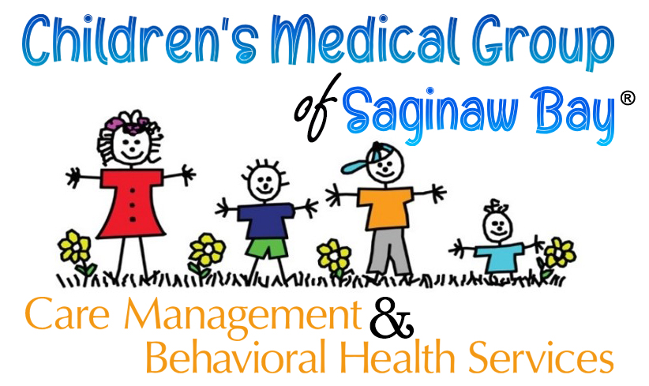



* **Acute, Chronic, and complex Medical Conditions**
* **ADHD/ADD**
* **Adverse Childhood Experiences (ACEs) and Resilience**
* **Autism**
* **Asthma**
* **Behavioral Concerns**
* **LGBTQ**
* **Delays in Development**
* **Health and Nutritional Needs/Elevated BMI**
* **Mental Health**

**-Depression**

**-Anxiety**

**Moderate/Complex Care Coordination** Case management and coordination of services for our patients with acute, multiple, complex, and/or chronic care needs **Patient Education** Health education for our patients and their care givers to promote self-management, increase pro-active health care, and improve outcomes **Problem Solving** Solution focused, team based work to enhance and increase our patients’ successes, in all areas of their lives **Community Resource Coordination** Identification, referral, and coordination of local, state, and/or federal resources to enhance the lives of our patients **Empowerment and Care Planning** Identification of goals, action steps, and building skills to accomplish desired goals **Transitional Care** Post emergency department, urgent care, or hospitalization care in which care givers are provided with added support to proactively manage our patients’ health care conditions **Short-Term Counseling** Mental health counseling with a focus on prevention, goal attainment, and growth promotion

**Bay City Office:**

**Laurisa Cummings, LMSW**

**Rachel Keyes, LMSW, DP-C**

**Saginaw Office:**

**Kaitlyn Alverson, LMSW**

**Angela Haas, LMSW, CAADC, CBIS**

Ran